MATHS REVISION
CLASS VII

- In a class test containing 15 questions, 4 marks are given for each correct answer and (-2) marks are given for every incorrect answer. James attempts all the questions but only 9 of his answers are correct. What is his total score?
- A postman walks $5\frac{3}{5}$km in a day. How much distance will he cover in $5\frac{1}{2}$ days?
- 3.45 ÷ 25 = __
- Simplify
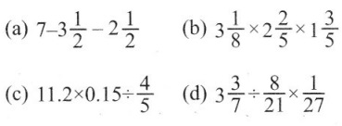
- If 21.875 litres of oil is in 312 cans of tin of equal capacity, find the capacity of oil in each can.
- Add: 0.0906, 0.00738, 0.1079, 0.03076, 0.4307
- A fair die is rolled, find the probability of getting a prime number.
- If the averages of the given data 6, 10, 12, x, 16 is 14, find the value of x.
- The following bar graph shows the number of books sold by a publisher during the five consecutive years. Read the bar graph and answer the following questions:
(i) About how many books were sold in 2008, 2009 and 2012 years?
(ii) In which years were 575 books were sold?
(iii) In which years were the minimum number of books sold? 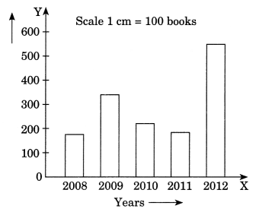
- The data given below shows the production of motorbikes in a factory for some months of two consecutive years.
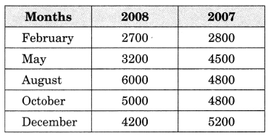
Draw a double bar graph using an appropriate scale to depict the above information and compare them.

